In all, there are five unique operations or bus cycles possible:
1. Memory read: MOV BX, [MEMWDS]
2. Memory write: (MOV [MEMWDS], BX
3. I/O read: IN AL, DPORT
4. I/O write: OUT DPORT, AL
5. Bus idle (internal operation not requiring access to memory or I/O: INC AX
Examining the address lines only, it is not possible to determine if this is a memory or an I/O address. Neither can you tell the direction of the data flow. That is, is the CPU performing a read or a write cycle? For this reason a control bus is required
this bus consists of the four active-low signals 1. MEMR 2. MEMW 3. IOR 4. IOW
Tl. The processor outputs the 20-bit memory address. The data lines are open circuited and all control lines disabled
T2. The MEMR control line is driven low. The memory unit recognizes this bus cycle as a memory read and prepares to place the addressed byte or word onto the data lines.
T3. The microprocessor configures its data bus lines for input but takes no further action. This state is provided primarily to give the memory time to “look up” the data byte or word.
T4. The microprocessor now expects the data to be on the data bus lines. Therefore, it latches the contents of these lines and releases the memory read control signal. This marks the end of the bus cycle.
Microprocessor controls all the bus timing.
The memory must be able to supply the selected data byte or word by the time MEMR goes high during the T4 state. If it cannot do so, the CPU will read random information on the data bus lines. This will lead to unpredictable results.
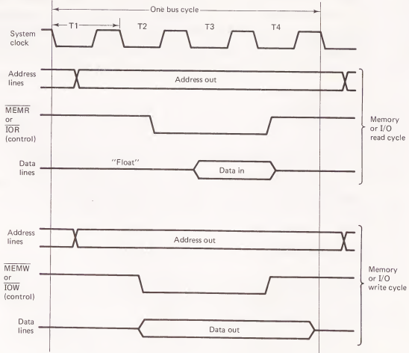
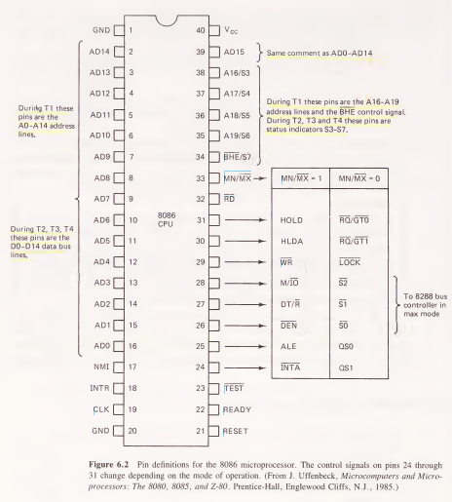
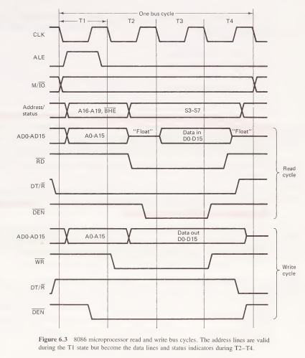

In fact, the 8086 has a 20-bit address bus, 16-bit data bus, three power pins, and 17 pins devoted to miscellaneous control and timing functions
The “trick” employed by Intel to make this work is called time multiplexing. This is a design technique in which one circuit pin has more than one function. For example, the 8086’s 16 data pins (labeled AD0-AD15) are address lines during the T1 clock state, Sec. 6.2 Basic 8086 CPU Hardware Design 225 but become data lines during the T2-T4 states.
A special “demultiplexing” circuit is required to extract the separate data and address lines
Using time multiplexing the pin breakdown becomes
16 data and address pins, 4 address (and status) pins, 3 power pins, 17 control and timing pins
Another interesting feature of the 8086 is its ability to operate in a minimum mode or a maximum mode. Minimum mode is intended for simple single-processor systems on one printed circuit board (PCB).
Data bus (AD0-AD15): These 16 pins form the CPU’s bidirectional data bus. These lines are valid only during the T2 through T4 clock states. During T1 they hold the low 16 bits of the memory or I/O address.
Address bus (AD0-AD15 and A16/S3-A19/S6): These 20 pins correspond to the CPU’s 20-bit address bus and allow the processor to access 1,048,576 unique memory locations. These output lines are valid only during the T1 state, switching to become the data and status lines during the T2-T4 clock states.
Address latch enable (ALE): The signal output on this pin can be used to demultiplex the address, data, and status lines on AD0-AD15, A16/S3-A19/S6, and BHE/S7
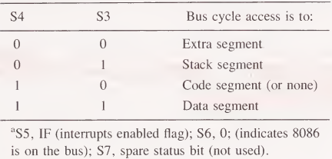
Memory/IO (M/IO): The 8086 does not output separate memory and I/O read and write signals. Instead, the M/IO signal is output early in the T1 state and identifies the current bus cycle as a memory (M/IO = 1) or I/O (M/IO = 0) operation.
Read (RD): This active-low output signal indicates that the direction of data flow on the bus is from memory or I/O into the processor.
This active-low output signal indicates that the direction of data flow on the bus is from memory or I/O into the processor.
It is output during the T2 state and removed during the T4 state.
The memory or I/O device is assumed to have placed the addressed byte or word onto the data lines by the time RD returns high.
Write (WR): This signal is the counterpart of RD and indicates that data is to flow from the CPU to memory or to an I/O device.
In either case, the data is output during the T2 state.
This gives the memory or I/O plenty of time to latch the data byte or word before WR is removed during T4.
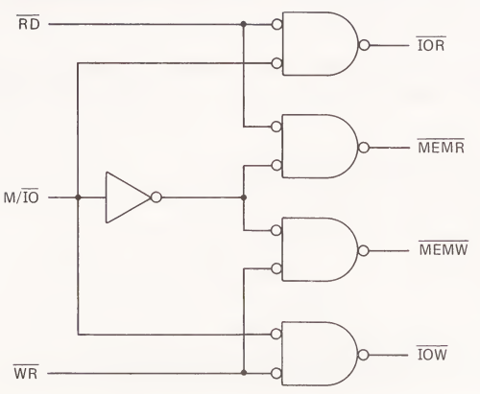
Status (A16/S3-A19/S6 and BHE/S7): These five status signals are output during states T2-T4. They are intended primarily for diagnostic testing purposes. It is possible to decode S3 and S4 to provide four separate 1MB address spaces for the extra, data, code, and stack memory segments.
Bus high enable (BHE/S7): This signal is multiplexed with the S7 status indicator. It is output only during the T1 state. When BHE is low, it indicates that AD8-AD15 are involved in the data transfer. BHE and AO are typically used to select even or odd memory banks or I/O ports.
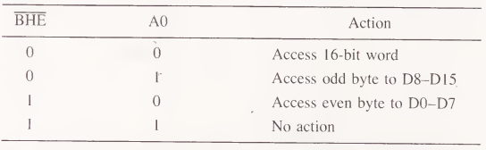
Data transmit/receive (DT/R): This signal is intended to control the direction of data flow through the buffers (if any) connected to the system data bus. When low it indicates a read operation, and when high, a write operation.
Data enable (DEN): This signal is intended to be used with DT/R to enable a set of bidirectional buffers connected to the system data bus. It prevents bus contention by disabling the data bus buffers until the T2 state, when the address/data lines no longer hold the memory or I/O address.
Minimum/maximum mode (MN/MX): the 8086 can be operated in one of two modes called the minimum and maximum modes. minimum mode (MN/MX = 1)
RESET: When pulsed high this input causes the 8086 to terminate its present activity arid perform a reset sequence. The status of the “old” job is lost. RESET is normally used when first starting the system or after a system crash.
READY: The READY input is sampled on the rising edge of the T2 clock pulse. If this line is found low (“not ready”), an extra T3 state is inserted by the processor. The cycle repeats until the READY input is found high. The READY input is usually driven by a slow-memory device that cannot supply data as fast as required with normal CPU timing.
Interrupts (INTR, NMI, and INTA): INTR and NMI are hardware-initiated interrupt requests that function exactly as software interrupts. NMI is rising-edge triggered and INTR is an active high-level trigger. The INTR input can be masked by resetting the IF processor status bit (CLI). NMI is a nonmaskable interrupt that will always be serviced.
When NMI is active, control automatically transfers to the address stored in locations 00008-0000BH. When INTR is active an interrupt-acknowledge cycle is performed. This is similar to a memory read cycle except that INTA is active instead of RD. The interrupting device is expected to place an 8-bit type number onto the low-order data bus. Control then transfers to the address stored in locations type x 4 through type x 4 + 3.
Hold and hold acknowledge (HOLD and HLDA): HOLD is an active-high CPU input that causes the processor to open circuit all of its bus lines. This effectively disconnects the CPU from its memory and I/O, allowing a second processor to access these devices. This is referred to as direct memory access (DMA). HLDA acknowledges the DMA request to the DMA controller
Power and ground (l/cc and GND): The 8086 requires a single + 5-V power source and has two ground pins.

GENERATING THE 8086 SYSTEM CLOCK AND RESET SIGNALS
The 8086 requires a clock signal with fast rise and fall times (<10ns), logic 0 and 1 levels of —0.5 to 0.6 V and 3.9 to 5.0 V, respectively, and a duty cycle of 33%.
The processor’s RESET signal must be synchronized to the system clock and persist for at least 4 T states.
8284A clock generator This IC meets all the requirements mentioned for the clock and RESET signals and can also be used to synchronize wait requests from slow-memory parts.
The 8086 Clock Signal:
all the activities of the 8086 are sequential and synchronized to a system clock signal
Without the clock signal to synchronize these events, we would have chaos. The memory and I/O devices need the setup and hold times provided by the basic four-clock state bus cycle
the microprocessor is designed with dynamic logic gates that require periodic “refreshing” or they will lose their data. The clock signal provides this refresh. For this reason the clock must never be stopped. In fact, the 8086 has a minimum operating frequency specification (2 MHz) as well as a maximum.
Generates the System Clock for the iAPX 86, 88 Processors: 5 MHz, 8 MHz with 8284A 10 MHz with 8284A-1
Uses a Crystal or a TTL Signal for Frequency Source
Provides Local READY and Multibus READY Synchronization
18-Pin Package
Single +5V Power
Supply Generates System Reset Output from Schmitt Trigger Input
Capable of Clock Synchronization with Other 8284As
Available in EXPRESS - Standard Temperature Range - Extended Temperature Range

The clock source can be an internal crystal oscillator (F/C = 0) or an external frequency input (F/C = 1) applied to the EFI pin. In either case a divideby-3 counter provides the necessary 33% duty cycle

The 8284A has three frequency outputs. OSC is a TTL-level signal with a frequency equal to that of the internal crystal oscillator. PCLK is a TTL-level peripheral clock with frequency one-half that of the 8086 clock and a 50% duty cycle. CLK is the processor clock. Its frequency is one-third that of the crystal oscillator or EFI input and has a 33% duty cycle.

The CSYNC input allows the system clock to be synchronized to an external event. It can also be used to synchronize multiple 8284As to provide clock signals that are in phase

"Cold Starting" the 8086
When power is first applied to the 8086, all its internal registers contain random data. This also applies to its read/write memory (RAM). Because of this, the processor will fetch its first instruction from a random memory location (containing a random instruction), leading to an unpredictable result.
It is quite likely that the CPU will “tie itself up” in a loop endlessly executing some random group of instructions.
some means must be provided for gaining control of the machine when it is first started. This is the purpose of the RESET input. When this pin is driven high, most of the 8086 CPU registers are reset
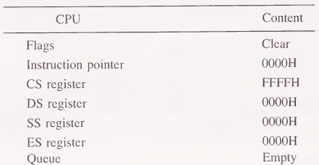
RESET thus solves the random-start-address problem associated with “cold start¬ ing” the processor.
We must ensure that a useful program resides in memory beginning at the reset start address FFFFOH. Note that RAM cannot be used at this address, as this memory will be storing random data when power is first applied
There are only 16 bytes between addresses FFFFOH and FFFFFH (the end of memory), so the instruction at FFFFOH is normally a “jump” to some other location where a longer program resides (again in ROM).
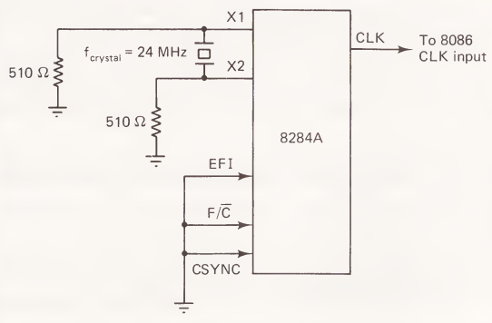

Generating the RESET Signal:
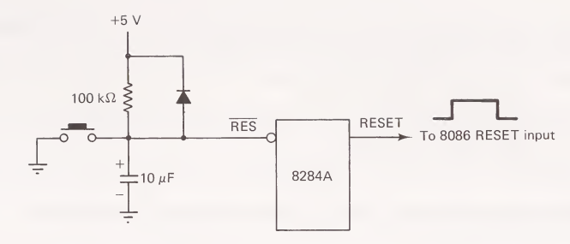
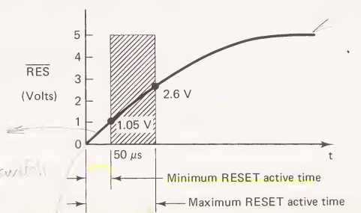
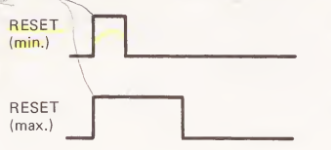
The RES input is synchronized to the falling edge of the system clock signal
The RESET output will be held high for an integral number of clock pulses until the switch is released. The 8086 will then begin execution at address FFFFOH
The circuit also provides a power-on reset function. when power is first applied to the system, the capacitor will charge toward + 5 V. With a sufficient time constant, the RES input will be held low long enough to reset the processor.

THE 8086 MINIMUM-MODE CPU MODULE
Minimum Mode Operation:
- The 8086 operates in minimum mode when the MN/MX pin is wired to +5 V. In this mode, the CPU generates all the control signals, suitable for small- to medium-sized single-processor systems.
Demultiplexing Address/Data Bus:
- The 8086 multiplexes address and data lines, which need to be demultiplexed for most memory and I/O devices. Demultiplexing separates the address and data signals using transparent latches like the Intel 8282/8283.
- 8282/8283 Octal Latch: Demultiplexes the address/data lines and buffers them. The 8282 outputs non-inverted signals, while the 8283 inverts the input data.
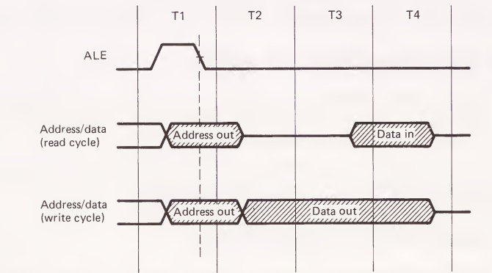
8282/8283 OCTAL LATCH
Address Latch for iAPX 86, 88, 186, 188, MCS-80®, MCS-85®, MCS-48® Famlies
High Output Drive Capability for Driving System Data Bus
Fully Parallel 8-Bit Data Register and Buffer
Transparent during Active Strobe
3-State Outputs
20-Pin Package with 0.3” Center
No Output Low Noise when Entering or Leaving High Impedance State
Available in EXPRESS - Standard Temperature Range - Extended Temperature Range

Minimum Mode CPU Module Design:
It incorporates the 8284A clock generator and reset circuit, three 8282 octal latches for demultiplexing the address/data lines, and a simple gating array to develop the standard memory and I/O control signals.
The address lines are labeled AB0-AB19, where the “B” is used to indicate that thesfe lines are buffered.
The four status lines S3-S6 are not used, being intended primarily for diagnostic
testing, as mentioned previously. The control bus includes the signals BHE (demulti¬
plexed), INTA, and RESET, as these signals may also be required in the memory and
I/O interfaces.

Address/Data Line Handling:
- During the ALE high signal, the latch is transparent, allowing address lines to pass through. After ALE falls, the address is stored while data is passed later during the T2 clock cycle.
Driving TTL Loads:
- The 8282/8283 can drive up to 20 standard TTL loads in the low state and up to 125 loads in the high state. It offers noise immunity with values of 0.4 V (high level) and 0.35 V (low level).
CPU Module Design:
- The module includes:
  - 8284A clock generator.
  - Three 8282 octal latches for demultiplexing.
  - Tri-state buffers enabled via HLDA for address and control bus signals.
  - Pull-up resistors to ensure control signals remain inactive during DMA cycle transitions.
Troubleshooting:
- Power Supply: Ensure stable power supply within 5-10% of nominal values.
- System Clock: Check for a proper 30% duty cycle square wave.
- Address/Data and Control Signals: Use a logic probe to observe pulsing signals, indicating proper switching.
- Test Program: A simple program like MOV AX, 5555H followed by an OUT instruction can confirm basic CPU function and signal execution.
Testing with Logic Analyzer:
- Monitoring memory fetches and bus activity using a logic analyzer helps verify bus timing and potential glitches due to unequal delays through buffers.

